HCI Project 3

By Brian Nguyen, Woo-Jae Lee, and Cody Fulford

University of Calgary

CPSC 481 - HCI

# Affinity Diagram

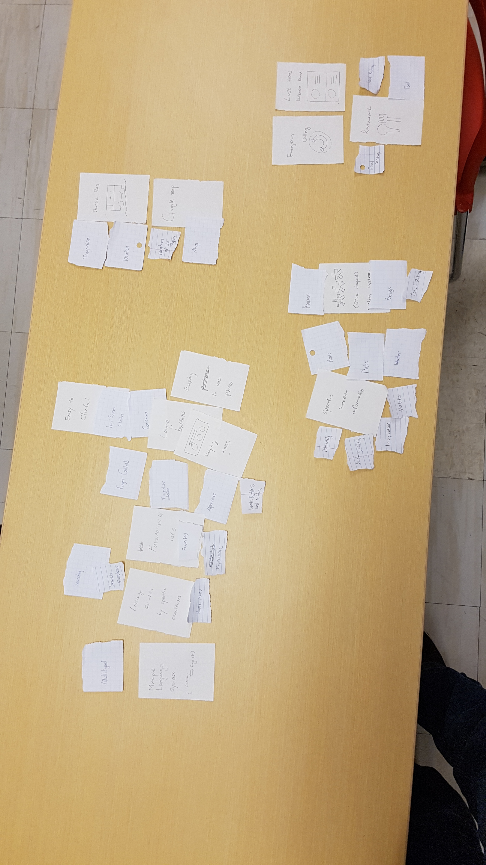

To develop our affinity diagram, we first each drew some sketches for the user interface. We did these drawings individually so that we could bring the ideas together at the end and compare the ideas from different perspectives. Next we discussed the strengths and weaknesses of our sketches by going through them one by one. We took turns speaking about our sketches while the other group members took notes about the strengths and weaknesses of their idea. After that each group member had a list of important design concepts from the sketches. After enumerating these design concepts, we spread them across a table and grouped them up into separate categories. Initially we had eight different categories for our design concepts:

* Important application design concepts (usability, modularity)
* Skill hill information
* Ratings
* Ski hill services
* Restaurants
* Transportation
* Emergency Services
* Multiple languages support

Finally, we reduced and combined these categories into four categories:

* Skill hill information
* Services that the resort offers
* Application design (usability, modularity, ease of use)
* 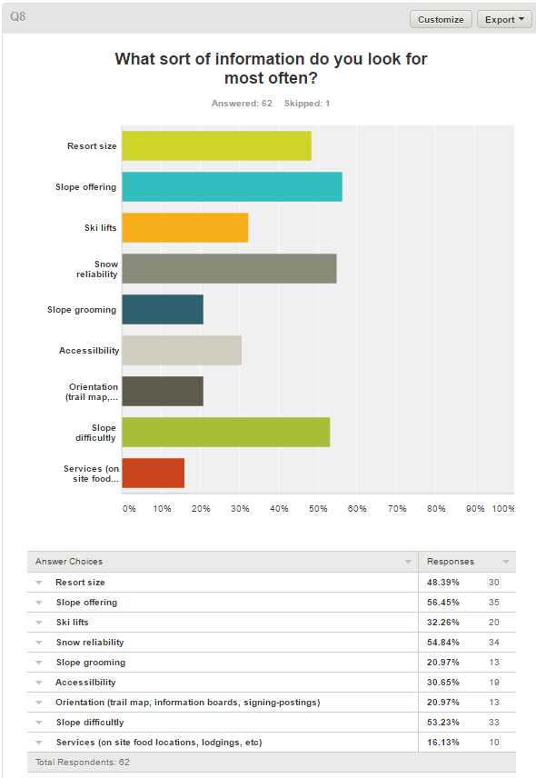Transportation (location of resort, restaurants)

Per our survey results, we could identify the major features that customers want to know about a resort. Upon reflection of our sketches, we also produced similar results namely: weather, location, ski hill availability, and price were the major features that our application must have. These features are under the skill hill information category.

We also recognized that since our users would be cold and wearing gloves most of the time, an ideal app for the users would include buttons that are large. We also thought that a minimalistic design is ideal, perhaps a main menu that includes only the essential things. These concepts were included under the application design category.

We noticed that we had several concepts related to transportation, namely resort and restaurant location, distance to the resort, and an overview of resort.

# Polished Versions

We have chosen these three designs as the most promising for satisfying our customer’s needs. The main need for our users is ease of use. This is because our users will often be in a hurry to find the information that they need, or on a ski hill where they will be, for all intents, disabled. While our customers will not actually be disabled, it is important to think of them as such because of the gloves that many skiers wear. These gloves greatly increase the size of their fingers and reduce the responsiveness of the touchscreen. Even the gloves that are specially designed to work with touchscreens increases the size of the finger. Should the customers gloves not work with the touchscreen, it is possible that they will remove the gloves to use the app. This means that the users hags will most likely be cold and shaking. These limitations that the user will probably have sound very similar to what we would have to design for older people. We can also assume that the customers will be using the application with both hands since they will be standing over the snow. We assume that the customer will hold the phone with one hand and use it with the other. If the customer leaves their glove on the hand that is holding the phone, the extra bulk of their gloves will cover some portions of the screen. The area that the gloves can cover will mostly be the middle of the vertical portion of the screen, extending towards the middle of the screen.

